
Student's Name Design Log Portfolio
This is my design log portfolio share page to show my top 3 projects each including a title, summary, image, peer support, conclusion, and 2 resource links.

Project Title 1
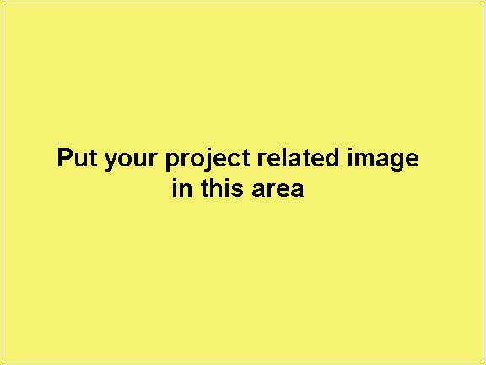
Three sentences, summarizing your project here.

Process or Steps (SPICE):
Situation: What is the big picture of this project
Problem/Challenge: What has to be made, what are the requirements, and what is to learn
Investigation/Ideas: What ideas did you get, where did you find your ideas
Create/Construct: What were your steps to make or solve for your challenge/project goals
Evaluation: How does the end fished product/solution support or meet the challenge
Peer Assistance: Who supported you and how, in one sentence.

Related Resource Links
- Resource link sample 1
- Resource link sample 2

Conclusion
What did you gain and/or learn - knowledge, skills, and/or values from this project?

Project Title 2
Three sentences, summarizing your project here.

Process or Steps (SPICE):
Situation: What is the big picture of this project
Problem/Challenge: What has to be made, what are the requirements, and what is to learn
Investigation/Ideas: What ideas did you get, where did you find your ideas
Create/Construct: What were your steps to make or solve for your challenge/project goals
Evaluation: How does the end fished product/solution support or meet the challenge
Peer Assistance: Who supported you and how, in one sentence.

Related Resource Links
- Resource link sample 1
- Resource link sample 2

Conclusion
What did you gain and/or learn - knowledge, skills, and/or values from this project?

Project Title 3
Three sentences, summarizing your project here.

Process or Steps (SPICE):
Situation: What is the big picture of this project
Problem/Challenge: What has to be made, what are the requirements, and what is to learn
Investigation/Ideas: What ideas did you get, where did you find your ideas
Create/Construct: What were your steps to make or solve for your challenge/project goals
Evaluation: How does the end fished product/solution support or meet the challenge
Peer Assistance: Who supported you and how, in one sentence.

Related Resource Links
- Resource link sample 1
- Resource link sample 2

Conclusion
What did you gain and/or learn - knowledge, skills, and/or values from this project?

Peer Feedback by: _______________
In a couple of sentences, give one critical and one positive feedback response of your fellow peers work, based on the above projects selected.

Term 1 Weekly Summary Log Report
The information on your daily log sheets will be used to summarize your accomplishments for the week by reporting on tasks complete and your learning process through new knowledge, skills, and/or values.

New Learning: KNOWLEDGE – information, SKILL – practical work done, VALUE – new opinion/feeling based on K/S
End of: /0.5 | Major Tasks: /1 | Learning/Process/Accomplishments (K/S/V): /1.5
Week 2:
/ /

Day, Month, Year
Week 3:
/ /

Day, Month, Year
Week 4:
/ /

Day, Month, Year
Week 5:
/ /

Day, Month, Year
Week 6:
/ /

Day, Month, Year
Week 7:
/ /

Day, Month, Year
Week 8:
/ /

Day, Month, Year
Week 9:
/ /

Day, Month, Year

Term 2 Weekly Summary Log Report
New Learning: KNOWLEDGE – information, SKILL – practical work done, VALUE – new opinion/feeling based on K/S
End of: /0.5 | Major Tasks: /1 | Learning/Process/Accomplishments (K/S/V): /1.5
Week 10:
/ /

Day, Month, Year
Week 11:
/ /

Day, Month, Year
Week 12:
/ /

Day, Month, Year
Week 13:
/ /

Day, Month, Year
Week 14:
/ /

Day, Month, Year
Week 15:
/ /

Day, Month, Year
Week 16:
/ /

Day, Month, Year
Week 17:
/ /

Day, Month, Year

Final summary/conclusion:

