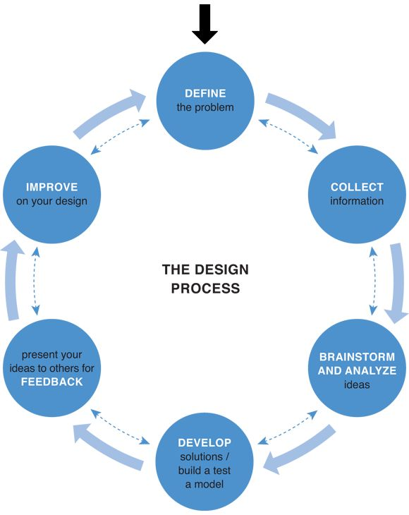
[Your Project Title]

Project
  - [Select Date]
  - Name:

  - Section:

Overview
Understanding the SPICE design model (one of many out there) will help you to be successful in a series of practical steps to solve a problem. Using this document will help you with entering and applying SPICE to any situation, allowing you more understanding and success to this process.

Situation /5
[Describe the big picture, the background, how this project came about, and who is involved to get an idea-understanding on the bearing/direction of the project/purpose. Also establish a baseline of knowledge/skill level.]
Note: To add your own content, click on this blue box tip, and just start typing, to add your own input.
Example:
Currently in Technology X program learning about its related field consisting of engineering design, communications, and standards. Recently was successful with related course Y. I have always had an interest in XYZ, and looking at project X that will enable me to practice and broaden my knowledge, skills, and values for further learning and experience in this engineering field related project X.

Problem/Challenge /10
[Problem/challenge is the scope that defines the boundaries of a project. The challenge/problem is to be identified, with must-have requirements/criteria, limits, extents, and time. It is what you want to accomplish and or resolve.]
Example:
Require a project solution/widget XYZ with:
- purpose/function of project/idea… design a widget to do XYZ…
- size and/or scope
- limits and/or extents
- available related resources
- time constraints

Ideas/Investigation /4
[Show how, what, and where you would generate a lot of ideas from, such as your own experiences, peers, internet, and/or related professionals. Locate support resources, information, illustrations, pictures, equipment, tools, materials, and process steps to help with the design, testing, prototyping, marketing, and build of the project. Remember this is a proposal with the initial direction, so the ICE part of this SPICE design model is not yet done and will show possible preliminary planning, steps, investigation, and ideas to support the Create/Construct step.]
Example:
For project X, planning steps and ideas will come from researching project X related information resources such as:
- Internet under multiple topics: topic/term 1, topic term 2, etc.
- Compare current possible solutions already resolved to modify for my requirements
- Consider process, materials, for prototyping and manufacturing
- Create lots of thumbnail ideas of widget XYZ possibilities

Create & Construct /2
[Show how and what you would select, for the best idea to use with the direction and completion of your project/idea (in the Problem/Challenge). This would include your final design, materials, steps to take, tools, and equipment used to complete the project.]
Example:
Narrow down to best idea based on Problem/Challenge criteria and constraints.
- Communicate final idea with full ortho/iso sketch with dimensions
- Create CAD model with detail drawing(s)
- Create prototype (cardboard, wood, 3D printing, etc.)
- Create final widget XYZ using intended manufacturing process and material(s)

Evaluation /2
[Once project is built/complete, it will need to be tested to see if it meets the criteria of the Problem/Challenge. If it doesn’t, you will need to
- go back to Ideas/Investigation step and look at other ideas and/or create more ideas
- refine Challenge/Problem to meet new criteria adjustment if needed
Eventually getting to a working solution, review process steps with reflection on what could be done better if you had to do it again.]
Example:
Project XYZ has been tested using several methods -test x, y, z, etc., showing that it meets all requirements and criteria – size, operation, time, durability, … etc.
Reflection on design process shows that more research would have helped with idea refinement. Speaking to professionals in industry gave me the best insight to my project widget XYZ solution, therefor will use this direction first to get better ideas.

Peer check and support /2
Below, double check your entries above and have a peer review your SPICE applied, with one positive comment, one practical/critical support comment, and an evaluation mark.
Name (last initial, first name) | Comments | Evaluation /25

